42.28: a) See Example 42.10: The probabilities are 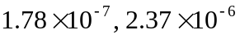, and 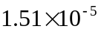. b) The Fermi distribution, Eq. (42.17), has the property that 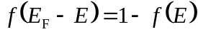 (see Problem (42.46)), and so the probability that a state at the top of the valence band is occupied is the same as the probability that a state of the bottom of the conduction band is filled (this result depends on having the Fermi energy in the middle of the gap).

